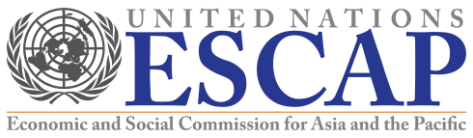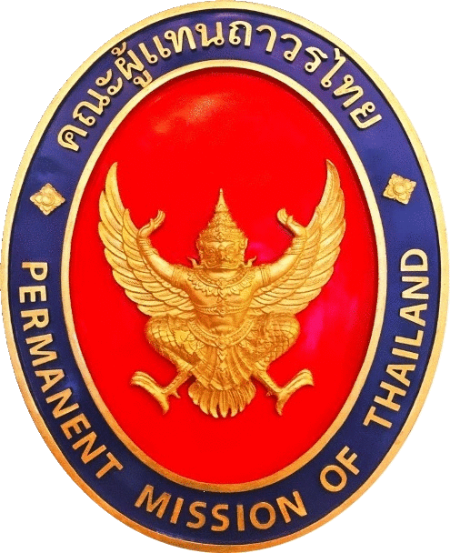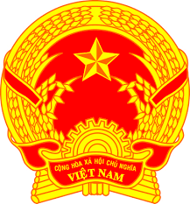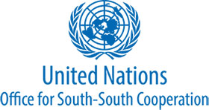

Invitation to a side event
during the 2019 High-level political forum under the auspices of the ECOSOC, on
“Regional contributions to empower people and promote equality: experiences, lessons learnt and way forward”
Thursday 11 July 2019, 13.15 – 14.30 hrs.
Conference Room F, United Nations Headquarters, New York

Regional cooperation continues to have a crucial role contributing to advancing sustainable development agenda. Inequality remains a challenge to be further addressed for all countries and regions. This event provides opportunity for different players across various regions to exchange their experiences, home-grown approaches and models, success stories and best practices, lessons learnt, challenges and way forward to empower people and address equality. It will also be a chance to explore ways to promote more inter-regional cooperation, including through the frameworks of South-South and Triangular Cooperation. The event will also touch on the ongoing repositioning of the UN development system, particularly the review of its regional architecture, which needs to gear towards strengthening the United Nations’ regional support and contributions towards SDGs.

This event is open to all participants of the 2019 HLPF. We look forward to your participation. For further information or questions, please contact Ms. Ratchaphorn Srisawang (ratchaphorns@gmail.com).



Provisional Agenda
13.15 – 13.20 hrs. | Opening remarks by H.E. Mr. Vitavas Srivivok, Ambassador and Permanent Representative of Thailand
13.20 – 14.00 hrs. | Panel discussion on “Regional contributions to empower people and promote equality: experiences, lessons learnt and way forward”  - Ms. Armida Salsiah Alisjahbana, Executive Secretary of the United Nations Economic and Social Commission for Asia and the Pacific (ESCAP)  - H.E. Mr. Ambassador Mr. Milenko Skoknic, Ambassador and Permanent Representative of Chile (from the perspective of Latin America)  - South Africa (from the perspective of Africa)  - M.L. Dispanadda Diskul, Mae Fah Luang Foundation, Thailand (from the perspective of civil society)  - Mr. Jorge Chediek, Director of the United Nations Office for South-South Cooperation (UNOSSC) and Envoy of the Secretary-General on South-South Cooperation  Moderator: Mr. Denis Nkala, Regional Coordinator for Asia and the Pacific, United Nations Office for South-South Cooperation (UNOSSC)
14.00 – 14.25 hrs. | Open discussion  Moderator: Mr. Denis Nkala, Regional Coordinator for Asia and the Pacific, United Nations Office for South-South Cooperation (UNOSSC)
14.25 – 14.30 hrs. | Closing remarks by H.E. Mr. Dang Dinh Quy, Ambassador and Permanent Representative of Viet Nam

**************************

