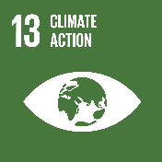
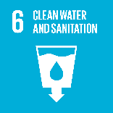
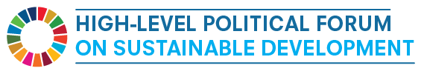

Side Event: Delivering Safe Drinking Water and Sanitation under the Current Climate Change Scenario – Innovative Responses from South-South Cooperation and Water Operators Partnerships

Co-Organized by the Permanent Mission of Tajikistan, the UN Office for South-South Cooperation and the Global Water Operators’ Partnerships Alliance/UN-Habitat with the support of the UN Department of Economic and Social Affairs

UN Secretariat (27th Floor, Room S-2724)
United Nations Headquarters, New York

Friday 12 July 2019
15:00 - 16:30

Draft Concept Note

BACKGROUND
“The year 2017 was one of the three warmest on record and was 1.1 degrees Celsius above the pre-industrial period. An analysis by the World Meteorological Organization shows that the five-year average global temperature from 2013 to 2017 was also the highest on record. The world continues to experience rising sea levels, extreme weather conditions (the North Atlantic hurricane season was the costliest ever recorded) and increasing concentrations of greenhouse gases. This calls for urgent and accelerated action by countries as they implement their commitments to the Paris Agreement on Climate Change.” – World Meteorological Organization

"As we face the spectre of growing unilateralism, protectionism and isolationism, it is increasingly vital that we empower partnerships for sustainable development. In this context, the efforts of the global South are gaining traction." - UN Deputy Secretary-General Amina J. Mohammed

The deregulation of the global climate is affecting the lives of people everywhere, but those in the Global South are particularly vulnerable, due to both their heightened exposure to climate perturbations and generally lower levels of resilience.

Climate change makes itself felt mostly through the water cycle, and water and sanitation utilities are already experiencing its effects. Strong water and sanitation utilities are essential to meeting the Sustainable Development Goal on water (SDG 6), itself a prerequisite for achieving most other SDGs. Yet many utilities, already struggling with weak operational and management approaches, inadequate resources and deteriorating infrastructure, are poorly prepared to adapt to a widening scope of challenges, such as floods that wash away significant parts of their networks or severe droughts that deplete water resources resulting in extreme water supply shortages.

For water and sanitation utilities, a deregulated climate is making water supplies less steady and predictable, and the normalization of droughts and other “extreme” events are exposing them more frequently to the risks of infrastructural damage and service cuts. Water scarcity affects more than 40 per cent of the global population and is projected to increase with climate change as over 1.7 billion people currently live in river basins where water use exceeds recharge. As steady safe water supply is a pillar of resilience, the ability for utilities to maintain safe supplies is also key to communities withstanding and bouncing back from all types of potential adversity.

Caribbean islanders, for example, live a harrowing climate duality. On the one hand, hurricanes in the region are notoriously ferocious. In August 2015, just days after a Caribbean operators’ training on strengthening resiliency to climate change, Hurricane Erika tragically took 20 lives on the island of Dominica. On the other hand, there are longer stretches of drought between rains, leaving crops thirsty and water utilities with diminishing supply. While receiving an unfair share of the impact of climate change, southern water and sanitation utilities also continue to contribute unduly to the GHG emissions that are the cause of this new climate crisis. High losses and water networks that rely on pumping heavy water resources across long distances mean that inefficiency in water utilities in the south are only worsening the problem. That’s the bad news.

The good news is that solutions such as groundwater recharge, wastewater treatment and reuse, watershed rehabilitation, rainwater harvesting, desalination, and reduction of non-revenue water, are increasingly discussed at the highest levels of management within the region’s water utilities. On the mitigation side, energy efficiency, transition to renewable sources and even energy generation in water utilities is growing. What’s more, learning is accelerating, twinning partnership relationships are being forged among utilities and in some cases, climate change mitigation and adaption funds offer new sources of financing for green and grey infrastructure. With threats mounting to water operations and sources, time is short to find solutions, but learning and experimentation is well underway.

Enhanced international cooperation is crucial for mitigating and adapting to climate change and South-South cooperation is gaining momentum as a meaningful approach to addressing this global challenge. The UN Office for South-South Cooperation (UNOSSC) and the UN-Habitat-led Global Water Operators’ Partnerships Alliance (GWOPA) are embracing the emerging capacity among southern water and sanitation utilities to address climate change. Structured exchange between peer utilities on a not-for-profit basis, called Water Operators Partnerships (WOPs), are an increasingly important form of South South Cooperation (SSC).

WOPs are based on the observation that capacity building and retention, facilitated by networking and mentoring, can equip service providers to meet water challenges. Most WOPs are South-South and many are helping utilities address climate change by helping utilities build sustainable capacity to reduce water losses, implement water safety plans, apply efficient and circular technologies, or develop inclusive pro-poor strategies. As the global climate reality becomes more extreme, a growing number of operators championing good climate change mitigation and adaptation practices, are highly motivated to share their expertise and innovation with others on a not-for-profit basis.

The event will give some examples of utility-led water and climate innovations in the developing south and showcase partnerships that are helping to share these approaches.

OBJECTIVES
The main objectives of this event are:
- To share knowledge and experience on integrated approaches for water and sanitation in support of climate change mitigation and adaptation.
- To present innovative responses from South-South Cooperation and call upon member states to promote and support those initiatives.

PARTICIPANTS
Participants will include representatives from public, private, and non-profit sector, as well as international organizations, civil society and practitioners involved in the research, development, management and implementation of integrated water programmes for sustainable development and climate change action.

CO-ORGANIZED BY:

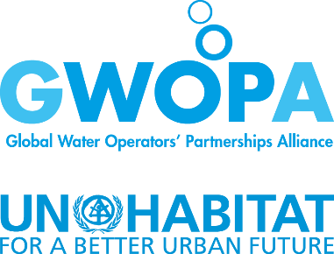
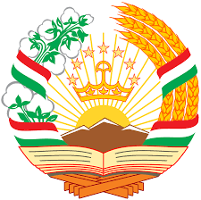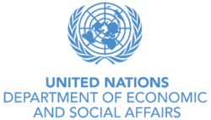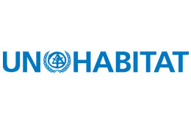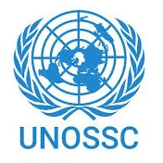
DRAFT PROGRAMME
15:00- 15:20 | Welcome Remarks:  - H.E. Mahamadamin Mahmadaminov, Permanent Representative of Tajikistan to the United Nations  Opening Remarks:  - H.E. Maimunah Mohd Sharif, Executive Director, UN-Habitat; Make our cities resilient: focus on UN-Habitat’s initiatives on climate change and basic services (TBC)  - H.E. Jorge Chediek, Director, UN Office for South-South Cooperation and Envoy of the Un Secretary-General on South-South Cooperation (TBC)
15:20– 16:20 | Sharing experiences on integrated water management for sustainable development and climate action  Moderator: Mr. Alexander Trepelkov, Officer-in-Charge, Division for Sustainable Development Goals, United Nations Department of Economic and Social Affairs (UN DESA) (TBC)  Presentations  H.E. Mr. Supark Prongthura, Permanent Representative of Thailand to the United Nations (TBC)  H.E. Mr. Mr David Mahlobo, Deputy Minister of Water and Sanitation, Republic of South Africa  H.E. Dr. Juan Avila Ceballos, Permanent Representative of the Dominican Republic to the United Nations (TBC)  Ms. Anne Bousquet, Programme Officer, the Global Water Operators’ Partnerships Alliance, GWOPA/UN-Habitat; “Building water utilities resiliency to climate change through Water Operators Partnerships”  Mr. Ignatius Jean, Caribbean Water and Sewerage Association; “Caribbean utilities joining forces to fight climate change”  Discussion and Questions
16:20– 16:30 | Closing:  - H.E. Mahamadamin Mahmadaminov, Permanent Representative of Tajikistan to the United Nations

In contrast to approaches which displace operators while changes are being implemented, WOPs aim to develop and maintain the resident human resource capital within a utility. In this light, WOPs also focus on the key role that workers, as well as managers, play in the delivery of safe and accessible water and sanitation services.

